**DAILY ONLINE ACTIVITIES SUMMARY**

|  |  |  |  |  |  |  |  |  |
| --- | --- | --- | --- | --- | --- | --- | --- | --- |
| **Date:** | **10-06-2020** | | | | | **Name:** | **Ashwini** | |
| **Sem & Sec** | **A** | | | | | **USN:** | **4AL17CS017** | |
| **Online Test Summary** | | | | | | | | |
| **Subject** | | **SSCD** | | | | | | |
| **Max. Marks** | | **30** | | **Score** | | | **27** | |
| **Certification Course Summary** | | | | | | | | |
| **Course** | **INTRODUCTION TO ETHICAL HACKING** | | | | | | | |
| **Certificate Provider** | | | Greatlearning  Academy | | **Duration** | | | 6hours |
| **Coding Challenges** | | | | | | | | |
| **Status: Done** | | | | | | | | |
| **Uploaded the report in Github** | | | | | **YES** | | | |
| **If yes Repository name** | | | | | <https://github.com/ashwiniachar/online-report> | | | |
| **Uploaded the report in slack** | | | | | **YES** | | | |

Online Test Details:

Subject:-CGV.

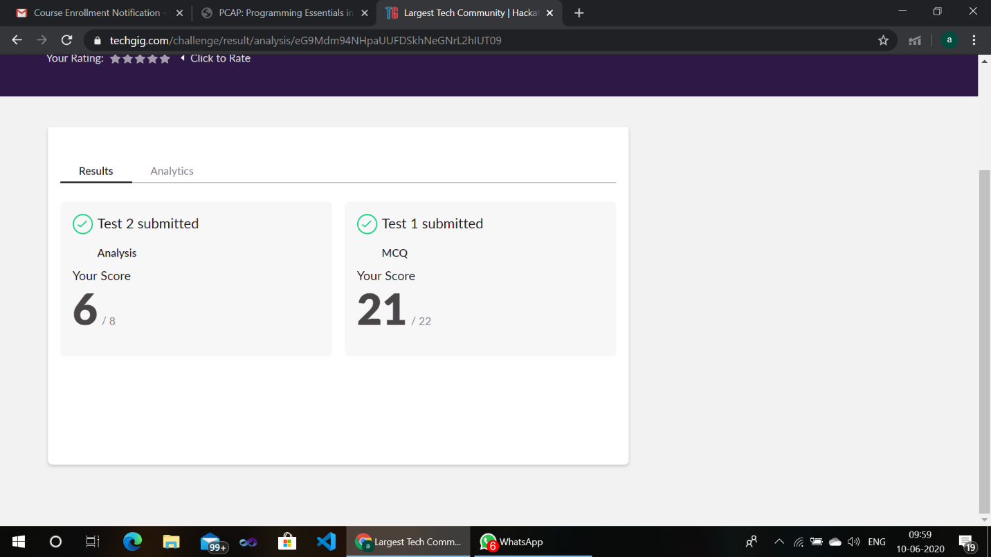CERTIFICATION COURSE:

**Introduction to Ethical Hacking:**

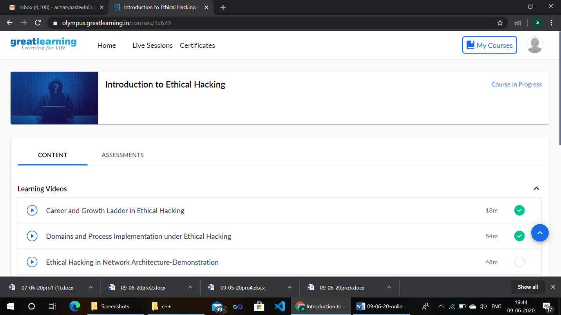

**Coding Challenges Details:**

1.Write a C Program to print the sum of boundary elements of a matrix

Given a matrix, the task is to print the boundary elements of the matrix and display their sum.  
Sample Output 1:  
Enter M (Rows) and N (Columns): 3, 3  
Enter the Elements: 1 2 3 4 5 6 7 8 9  
OUTPUT:  
The Input Matrix is:  
1 2 3  
4 5 6  
7 8 9  
The Boundary Elements are: 1 2 3 4 6 7 8 9  
The Sum of Boundary elements of the Matrix is: 40

Sample Output 2:  
Enter M (Rows) and N (Columns): 4, 5  
Enter the Elements: 1 2 3 4 5 6 7 8 9 10 11 12 13 14 15 16 17 18 19 20  
OUTPUT:  
The Input Matrix is:  
1 2 3 4  
5 6 7 8  
9 10 11 12  
13 14 15 16  
17 18 19 20  
The Boundary Elements are: 1 2 3 4 5 8 9 12 13 16 17 18 19 20  
The Sum of Boundary elements of the Matrix is: 147

#include<stdio.h>

#include<stdlib.h>

int main()

{

int **a,r,c,i,j;

printf("enter the size:");

scanf("%d",&r);

scanf("%d",&c);

a=(int**)malloc(r*sizeof(int*));

for(i=0;i<r;i++)

*(a+i)=(int*)malloc(c*sizeof(int));

printf("enter the matrix:\n");

for(i=0;i<r;i++)

{

for(j=0;j<c;j++)

{

scanf("%d",*(a+i)+j);

}

}

i=0;int sum1=0;

for(j=0;j<c;j++)

sum1=sum1+*(*(a+i)+j);

i=r-1;int sum2=0;

if(i!=0)

{

for(j=0;j<c;j++)

sum2=sum2+*(*(a+i)+j);

}

j=0; int sum3=0;

for(i=1;i<r-1;i++)

sum3=sum3+*(*(a+i)+j);

j=c-1; int sum4=0;

for(i=1;i<r-1;i++)

sum4=sum4+*(*(a+i)+j);

printf("Sum of boundary is %d",sum1+sum2+sum3+sum4);

return 0;

}

**Output:**

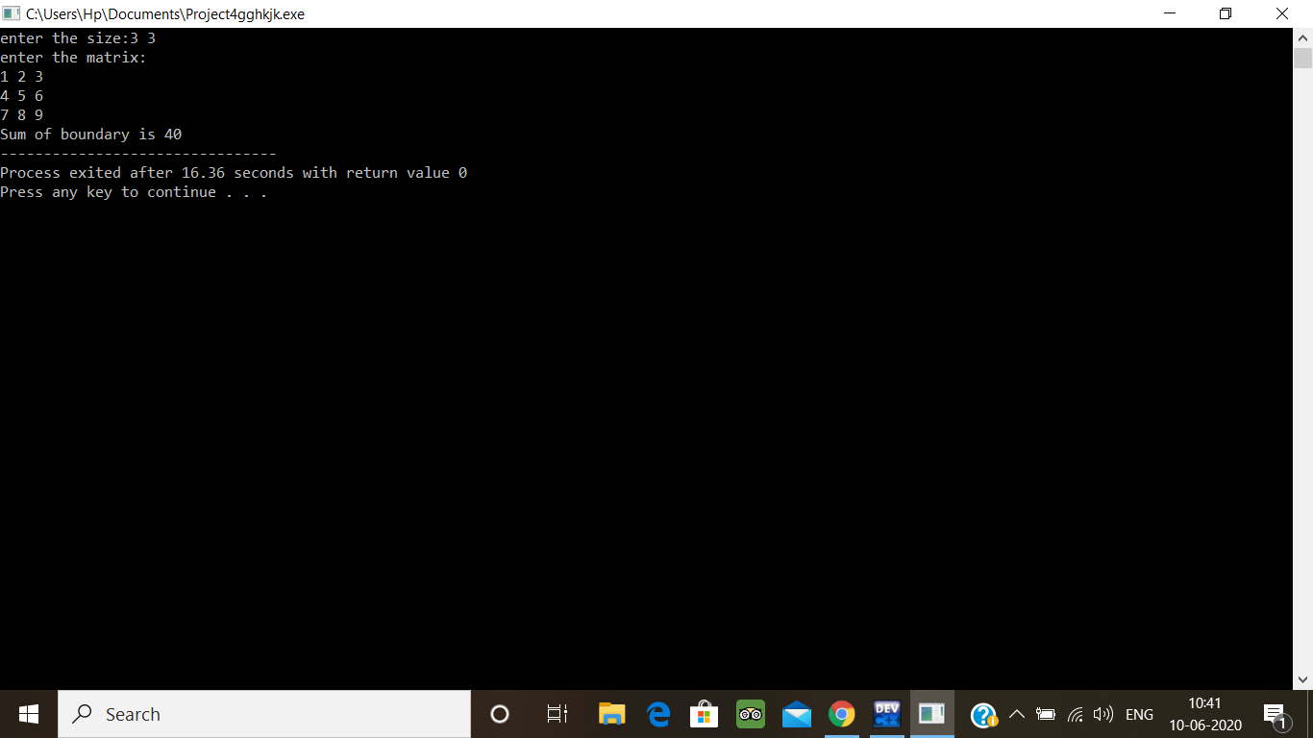

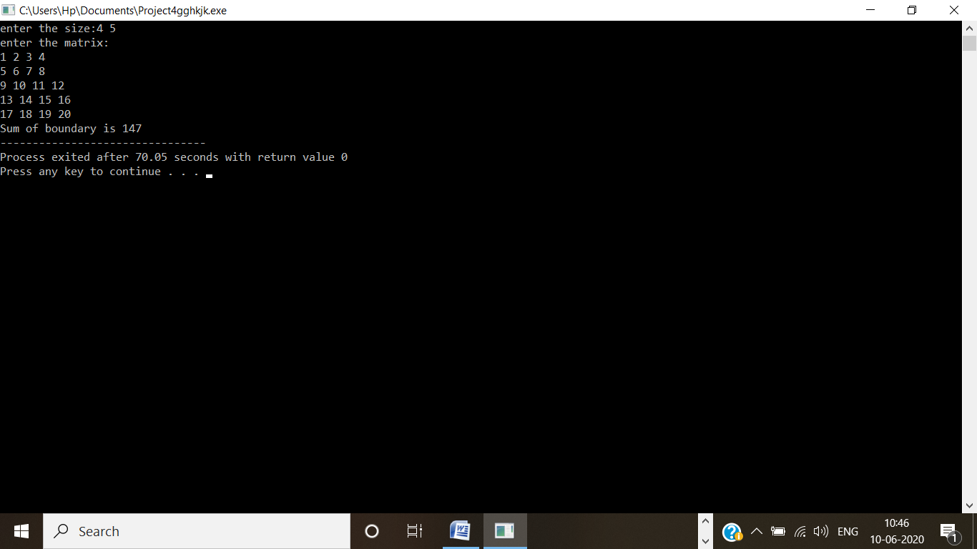

2) [Python Program to check whether a given number is a fibonacci number or not](https://github.com/orgs/alvas-education-foundation/teams/3rd-year/discussions/76)

